Name: _____________________

Exit Slip: Ancient Roman Geography

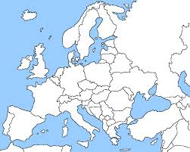

- Place an X on the location of Ancient Rome.
- Color the Mediterranean Sea blue.

Name: _____________________

Exit Slip: Ancient Roman Geography

- Place an X on the location of Ancient Rome.
- Color the Mediterranean Sea blue.

