Name: ______________________________

Ancient Rome Test

- The Ancient Romans had a type of government called a representative democracy. A representative democracy is _________________________.

- a government in which people vote to make their own rules and laws.
- a government in which the people vote for (elect) a smaller group of citizens to make the rules and laws for everyone.
- a government in which people do not get to vote.

- Look at the picture below. What example of Ancient Roman architecture do you see?

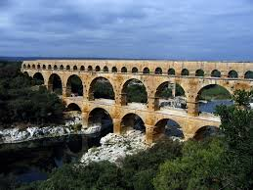

- a column
- an arch
- a sculpture

- Place an X on the map below to mark the location of Ancient Rome.

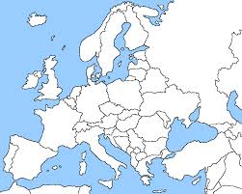

- What body of water is located next to Ancient Rome?

- the Atlantic Ocean
- the Red Sea
- the Mediterranean Sea

- Many Ancient Romans were ____________________, ______________________, and ___________________.

- farmers, road builders, and traders.
- bankers, shop owners, and tax collectors.
- writers, artists, and musicians.

- How did Ancient Romans adapt to their environment?

- They learned to use camels because Rome was located in a desert.
- They learned to farm hillsides and trade on the sea because Rome was located next to a river amongst many hills.
- They learned to hunt and gather food because Rome was located in the mountains.

- What contributions did the Ancient Romans make to us?

_________________________________________________________________________________________

_________________________________________________________________________________________

- How is the U.S. government similar to the government of the Ancient Romans?

_________________________________________________________________________________________

_________________________________________________________________________________________

- Historians use many different ways to learn about the Ancient Romans. How do we know important things about them?

_________________________________________________________________________________________

_________________________________________________________________________________________

- Look at the pictures below. Using the word bank, label where you can find each example of architecture.

Word Bank: Rome Greece U.S.

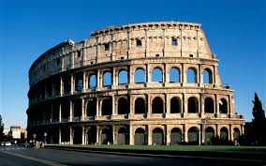 ________________________________

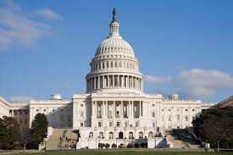 ________________________________

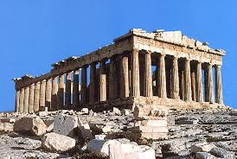 ________________________________

How are these pieces of architecture alike?

How are they different?

If you went back in time to Ancient Rome, what type of things would you see, hear, smell, feel, and taste. How do you know this?

Extension Question:

Would you rather live in Ancient Greece, Ancient Rome, or the U.S. today? Why? Think about lifestyle, government, and art when making your decision.

